Prof. Dr.-Ing. ANISITS FERENC Eduardshöhe 36, A-4540 Bad Hall
anisits@aon.at
Date of birth: 12/23/1938
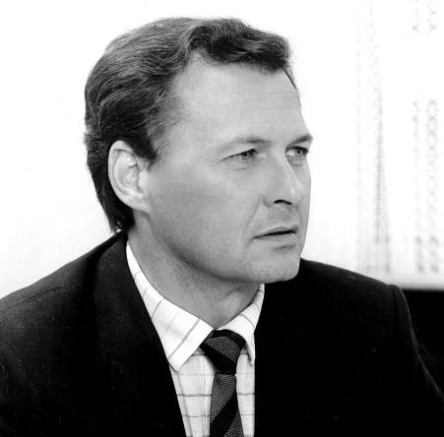
Education
---------------------------------------------------------------------------------------------------------
Szolnok, Sípos-téri állami népiskola [Sípos-téri State Grade School]
1945-1946 excellent
Miskolc IV. sz. állami általános vegyes iskola [Mixed State
Grade School No. IV]
1947-1948 excellent
Budapest
1948/1949 Homok-utcai általános iskola [Homok-utcai Grade
School]
excellent
1949-1951 Mária Terézia-téri gyakorló ált. iskola [Mária
Terézia-téri Grade School]
excellent
1951-1953 Homok-utcai általános iskola [Homok-utcai Grade
School]
excellent
1953-1957 Vörösmarty Mihály Ált. Gimnázium [Vörösmarty
Mihály High School]
GCSE, excellent
1956 armed involvement in the war for independence in Práter-utcai
School
1957-1962 Technical University, Budapest
Certified mechanical engineer, diploma, good
-------------------------------------------------------------------------------------------------------------
Work experience
Budapest Malomszerelő és Gépgyártó Vállalat [Mill Maintenance
and Machine Manufacturing Company]
1962-1964 food engineering development engineer
Szolnok Szolnoki Tervező Iroda [Designing Office of Szolnok]
1964-1965 building engineering designer
Augsburg (D) MAN (Maschienenfabrik Augsburg-Nürnberg)
1965-1973 applied research and experimental ship diesel engine developer
TU Braunschweig Promotion Dr.-Ing.
1973 jun. 26 (sehr gut bestanden)
Arbon (CH) Adolph Saurer AG
1973-1978 research & development manager (prokurist) diesel engine vehicles
Mannheim (D) MWM (Motoren-Werke Mannheim)
1978-1981 development manager for tractors and diesel propulsion machinery
Steyr (A) BMW
1981-1999 Diesel engine research & development center manager
------------------------------------------------------------------------------------------------------------------------------
Most outstanding achievements
Numerous theoretical and practical innovations (methods, processes and products)
Introduction of electrical control into series production,
Introduction of the first direct-injection V-8 diesel engine into series production,
BMW historic first victory with a diesel engine at the 24-hour Nürburg race,
Engine of the Year Awards in V6 and V8 engine categories in 1999 and 2000,
7.5 million diesel engines for different vehicles produced and sold until my retirement
-------------------------------------------------------------------------------------------------------------
Competencies and core competencies
Management, Marketing, methodical innovation, International Culture Competence, strategic management, etc.
-------------------------------------------------------------------------------------------------------------
Major publications, presentations and books
1969 calculation of the combustion flow of a diesel engine, MAN Research Day, MTZ (Motor Technische Zeitung), presentation at SAE Congress, Detroit (1971)
1971 calculation of the diesel engine injection process, MTZ
VDI Dieselmotoren Handbuch Springer Verlag 1. (1997) and 2. (2001) (author of the chapter on diesel engine vehicles)
Lectures: TU München, TU Berlin, TU Aachen, TU Dresden, ETH Zürich, BME, SAE Congress, CIMAC Congress, FISITA World Congress, etc.
1999 Best lecture of the symposium, Haus der Technik e.V. Essen
-------------------------------------------------------------------------------------------------------------
Professional acknowledgement
1978 Carl Benz Award (MWM)
1983 laudation of my lecture by Henry Ford II in Diesel R&D Center
1995 BME, honorary member of the University Council
1995 Ernst-Blickle-Preis,
2003 MTESZ Competitive Product Award,
2012 Botka Imre Award
Social acknowledgement:
1998 Silver Decoration of Honor of the Provincial Government of Upper Austria
1999 Ring of Merit of the City of Steyr
2001 Honorary Citizen of the City of Szolnok,
2015 Hungarian Order of Merit Officer’s Cross from the President of the Republic of Hungary,
2018 Honorary Professor of the University of Debrecen

