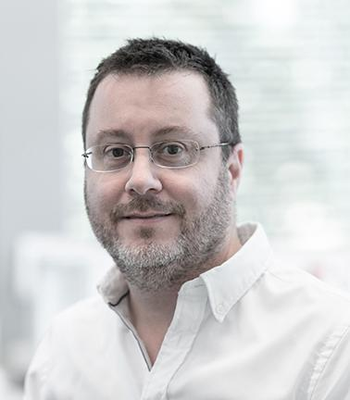

Dominik Schaer, MD, MBA, is a board-certified specialist in General Internal Medicine, Allergology, and Clinical Immunology. He practices as a Senior Physician and Deputy Director of the Department of General Internal Medicine at the University Hospital in Zurich. He leads an outpatient clinic for patients with systemic inflammatory diseases. Since 2018, he has been a Professor of General Internal Medicine at the University of Zurich, where he has been Vice Dean and Program Director for the study of Human Medicine since 2021. Over the past 15 years, Dominik Schaer has established a leading translational research program in Zurich, which, together with an internationally networked consortium from academia and industry, investigates how the oxygen carrier hemoglobin accelerates disease processes when red blood cells are destroyed in the blood or tissue. This program has yielded breakthrough insights into understanding clinical complications of hemolytic anemia and cerebral hemorrhage and has innovated new therapeutic strategies currently in clinical development. Dominik lives in Zurich, Switzerland, is a passionate sailor and skier, married, and has one son.

