LÁSZLÓ FÉSÜS (b. 1947, Hernádnémeti, Hungary)
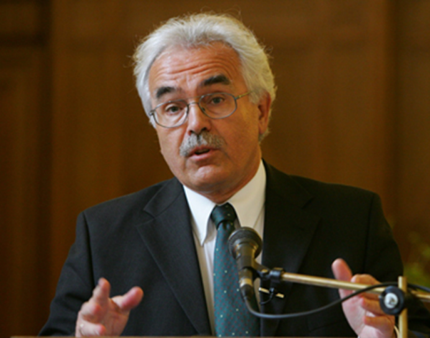

With his university degree in medicine, which he earned in 1972, László Fésüs got a job in Debreceni Orvostudományi Egyetem Kórélettan Intézet [Institute of Pathophysiology, Debrecen University of Medicine] after graduation. As a laboratory specialist, he has been one of the founders of Központi Klinikai Kémiai Laboratórium [Central Laboratory of Clinical Chemistry], the predecessor of Laboratóriumi Medicina Intézet [Institute of Laboratory Medicine].
He was appointed full professor in Biokémiai és Molekuláris Biológia intézet [Department of Biochemistry and Molecular Biology] in 1991, following which he headed the department for 20 years, while it has become an outstanding location for international cell-biochemistry research. He has been a visiting professor in Houston, Texas, and Rome, Italy. As one of the elected heads of FEBS (Federation of European Biochemical Societies), the association of biochemists in Europe between 2011 and 2021, and as the chair of FEBS Publications Committee, he founded FEBS Press, which publishes four international journals of biochemistry.
In the beginning, he studied immediate immune reactions. He spent three years in the USA between 1983 and 1985, where he directed the NIH laboratory of the National Foundation for Cancer Research, headed by Albert Szent-Györgyi. His research group in Hungary has, for more than 30 years, investigated the molecular mechanisms of apoptosis and enzyme effects, and it is currently focused on studying human thermogenesis and obesity. Publications by László Fésüs have generated more than 20,000 citations.
He was elected a member of the Hungarian Academy of Sciences (HAS) in 1998, and he presided over the Section of Biological Sciences of HAS between 2014 and 2020. He initiated and edited the first code of conduct for research of HAS. He is a member of the committee on research integrity of All European Academies (ALLEA); the body that issued the code known as European Code of Conduct for Research Integrity, of which he was one of the drafters and he also proofed the Hungarian version. The Academy of Europe, Academia Europaea, accepted him as a member in 2015.
László Fésüs was the last rector of Debreceni Orvostudományi Egyetem [University Medical School of Debrecen] and the first rector of the integrated Debreceni Egyetem [University of Debrecen, UD] in 2000. Between 2001 and 2007, he headed the Medical and Health Science Centre of UD as its president and chaired Magyar Akkreditációs Bizottság [Hungarian Accreditation Committee] between 2004 and 2006. In 2007, he was elected rector again. He has initiated and implemented several major investment projects and programs, such as Élettudományi Épület [Life Sciences Building], Auguszta Klinikai Tömb [Auguszta Clinical Block] and the new program for the research university status. He has also established a Statue Park, a Professors’ Club and a Museum of Medical History. He was also the founder of the prize Debrecen Award for Molecular Medicine and the periodical Gerundium, intended to serve as a record of the historical background of UD.
He has founded a new doctoral school, where twenty of his students have acquired their Ph.D. degrees, including academicians, full professors, clinical professors and directors of pharmaceutical research.
He has received the awards named after Albert Szent-Györgyi, Dénes Gábor, Ignác Semmelweis and István Széchenyi. László Fésüs is the honorary citizen of his home village and the city of Debrecen.

