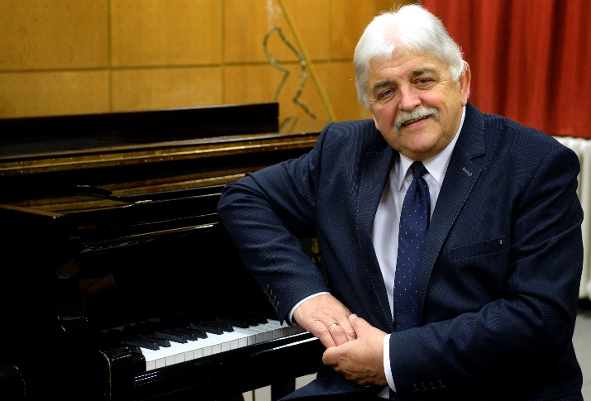

Curriculum
Vitae
Dr. habil. Mihály Duffek
pianist, full professor

Mihály Duffek was born in 1952 in Gödöllő, Hungary. He went to grade school and high school also in Gödöllő, and he started to learn to play the piano there, too. Later, he continued to study music in Budapest.
In 1972, he was admitted to the Piano Department of the Debrecen branch of Liszt Ferenc Zeneművészeti Főiskola [Ferenc Liszt College of Music], where he earned his certificate of piano teacher in 1975 as a student of Ilona P. Nagy.
From 1975 on, he attended the class of Kornél Zempléni in Liszt Ferenc Zeneművészeti Egyetem, Budapest, from where he graduated in 1979 as a certified piano performance artist.
In 2008, he received his diploma of Felsőoktatási menedzser [Higher education manager].
He started his teaching career in 1977 in the institution that was the legal predecessor of Debreceni Egyetem Zeneművészeti Kar [Faculty of Music, University of Debrecen] as a teacher of piano and instrument methodology.
In 1990, he was given the responsibility of heading the Piano Department, which he continued to do until 2017.
In 1992, he was appointed director and, in 2006, he was promoted dean at the Faculty of Music, which position he resigned from in 2017.
In 2005, he earned his DLA diploma and, in 2011, having completed the habilitation process, he was appointed full professor of the university.
As a concert artist, he gave concerts in the following countries in addition to Hungary: Romania, Slovenia, Austria Slovakia, Ukraine, Finland, Germany, Switzerland, France, Belgium, Great Britain, Spain, Italy, Cyprus, Israel, the US, Japan and South Korea. He also gave master courses in English and in Hungarian in the following countries: Spain, Finland, Japan, South Korea and Hungary.
He founded Ifjú Zeneművészek Nemzetközi Nyári Akadémiája [Young Musicians (International) Summer Academy] in 2001. He pursues doctoral school activities in Bölcsészettudományi Kar Humántudományok Doktoriskolája [Doctoral School of the Humanities of the Faculty of Humanities], where he acts as a teacher and a supervisor. He regularly publishes articles in periodicals on music pedagogy, methodology and institution history, and he has written a book on teaching the technique of playing the piano.
He has been married since 1978. He is the father of two children.
Mihály Duffek acts as the president of several public bodies, including Debrecen Kultúrájáért Alapítvány [Foundation for the Culture of Debrecen], DE Zeneművészeti Kar Fejlesztéséért Alapítvány [Foundation for the Development of the Faculty of Music of the University of Debrecen], and also as the co-president of Debreceni Egyetem Professzori Klubja [Professors’ Club of the University of Debrecen].

He has received the following awards:

1989: Honorary citizen of Tucson (Arizona, USA)
2006: Plaquette of Debreceni Akadémiai Bizottság [Debrecen Academic Committee]
2008: Debrecen Város Csokonai Díja [Csokonai award of the city of Debrecen]
2009: KÓTA Mecénás Díj [Maecenas award of Association of Hungarian Choirs, Orchestras and Folk Ensembles]
2016: Komlóssy Award
2017: Pro Universitate Award
2017: Pro Auditoribus Universitatis Debreceniensis Award
2017: Officer’s Cross of the Hungarian Order of Merit
2018: József Csanak Award
2018: Honorary Citizen of Debrecen
2018: Béla Tankó Memorial Award

